Advanced : Creating Custom Sounds

Reload this article and prepare it for printing.
(removes banner ad and menubar and sets new width for page)
This article was last updated on Wednesday, March 28, 2001
Written by:
Nemesis
nemesis@teamanarchy.com
What you will need:
1. A sound editing package. I recommend Syntrillium´s CoolEdit 96* (or CoolEdit Pro if you feel like shelling out the bucks.
2. A "tracker" program*. Trackers allow you to compose music (modules or "mods") by arranging digital samples in the order and pitch you want them (much like laying out notes on a staff). I recommend Fasttracker 2.08*. Most trackers are DOS based (it´s a tracker thing) and usually support SoundBlaster, GUS, or SB emulation. An .XM file has been included with this package for you to try the exercise below.
3. A good ear for music and a bit of patience. Learning to track songs takes time.
What you will NOT learn:
This tutorial will NOT teach you how to compose music or how to work a tracker. You´ll have to read the docs with the tracker or find an online FAQ*. There are also a good variety of tracking tutorials available online*. Beyond that, most music is taste so use your best judgement on what samples* to use and what kind of song you want.
This tutorial will also NOT teach you the art of Foley (making sound effects). Foley is based on pure ingenuity and is up to you to come up with (or find) the sound effects you want. Here´s a freebie (and an example of Foley): Smacking a head of lettuce with a broom handle sounds suprisingly a lot like a skull being cracked in...
On to the goods...
Part I: Music
Start by making a room to play around in (add a playerstart and lights). First thing you´ll need to do is create an unreal .umx music file. You can start by switching your browser (on the right) from Textures to Music. Click the Import button at the bottom and select your music file (created in FastTracker or something similar). Unreal supports .mod (standard mod file), .s3m/.stm (ScreamTracker format), .it (Impulse Tracker), .xm (extended mod format), and .far files.
Your music file will appear in the list to the right. From here you can play it if you wish to make sure it sounds correct. Just click Save and give your music file a name (such as "Trance.umx"--whatever you want). Now that your file is saved you can go to the Options menu, select Level Properties, go down to the Audio section, choose Song and click ´Use´ (make sure the song is selected in the list to the right). That will cause your song to be played for the duration of the level.
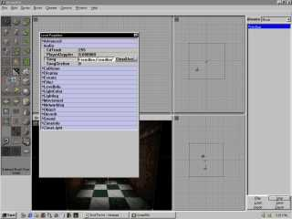
There are other ways to start songs (such as triggers) if you prefer to have a song keyed to and event (you have the option of playing it through only once using triggers). Try out the above with the included .XM file.
Part II: Sound without compromise
Sometimes finding the right sound for the job is easier said than done. After listening to every sound effect in Unreal and still not having what you want, you tend to get frustrated. Finally you decide, "Screw it, i´ll find a .wav or make my own." Well, if you´ve ever used Windows recorder than you know it´s sadly underpowered and churns out huge .wav files. Similarly, you may find the sound you want on the web but it´s about 5 times larger than it should be (you don´t want your level to be 3+ MB now do you?).
The thing to do is either A) record and edit your sound using a righteous sound editing tool (such as CoolEdit*) or B) get a pre-made sound into that same righteous sound editing tool. You´d be suprised how much quailty is retained by a sound file if it´s recorded at 44K/16bit/Stereo and then downsampled to 11 or 22K/16bit/mono. Use your sound editing package to do this downsampling. Listen for audio quality. You WILL find a nice compromise between quality and size.
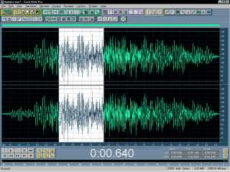
Once you´ve got your sound effects made and edited, fire up UnrealEd and switch the browser from Textures to SoundFX. Since you can´t just create a .uax audio file directly you can do one of two things: 1) Load up Extro.uax and delete the 7 sounds in there, Import your sounds, and save it under a different name (BE CAREFUL not to overwrite Extro.uax!) or 2) Just import your sounds into Extro.uax and leave them packaged in there with the first 7.
Now you´ve got exactly what you wanted in a sound, and it´s small so it doesn´t bloat your level up. You can check out the "Advanced Triggers" tutorial on unrealed.net for details on using triggers to fire off sound effects and music. If you have more questions about sound editing and music tracking you can contact me at nemesis@teamanarchy.com. Please do not bother the webmasters with sound editing/tracking related questions. Happy editing, and happy tracking!
*Some helpful links to references made above
CoolEdit 96 (ftp://ftp.syntrillium.com/pub/cool_edit/c96setup.exe)
Syntrillium Software (creators of CoolEdit) (http://www.syntrillium.com)
A good collection of Trackers (http://www.maz-sound.com/trackers.html)
The Zen of Tracking (online resource) (http://falcon.invincible.com/~jerm/newcomers.html)
Some samples to get you started (http://www.th-zwickau.de/~maz/instruments.html

